Analysis on Stock Market

Tilak Vijayaraghavan S1, Sarathram M 2, Radhamani V3

1 Student (Department of Computing, Coimbatore Institute of Technology)

2,  Student(Department of Computing, Coimbatore Institution of Technology)

3 Faculty (Department of Computing, Coimbatore Institute of Technology)

*Corresponding author’s email: stvraghavan@gmail.com

**Article Type:** Research Article

# Complete Detail of Each Author

First Author’s Full Name: Tilak Vijayaraghavan  
Highest Qualification: M. Sc. Decision and Computing Sciences  
Department: Decision and Computing Sciences  
Post/Rank (If a student, provide course name and course year): M. Sc. Decision and Computing Sciences 5th year   
Affiliation (College/University/Institute) with postal address: Coimbatore Institute of Technology, Avinashi Road, Civil Aerodrome, Peelamedu, Coimbatore 641014  
email id: stvraghavan@gmail.com  
ORCID:  N/A

Second Author’s Full Name: Sarathram   
Highest Qualification: M. Sc. Decision and Computing Sciences  
Department: Decision and Computing Sciences  
Post/Rank (If a student, provide course name and course year): M. Sc. Decision and Computing Sciences 5th year   
Affiliation (College/University/Institute) with postal address: Coimbatore Institute of Technology, Avinashi Road, Civil Aerodrome, Peelamedu, Coimbatore 641014  
email id: sarathrammsr07@gmail.com  
ORCID: N/A

Third Author’s Full Name: Radhamani V  
Highest Qualification: M.Sc. Computer Science  
Department: Decision and Computing Sciences  
Post/Rank (If a student, provide course name and course year): Assistant Professor  
Affiliation (College/University/Institute) with postal address: Coimbatore Institute of Technology, Avinashi Road, Civil Aerodrome, Peelamedu, Coimbatore 641014  
email id: vradhamani@cit.edu.in  
ORCID: N/A

ABSTRACT

With a never before seen dynamics in the world affecting the value of money across the globe, the option to save assets in the form of money is becoming more and more unstable. Investment becomes a mandatory, investment in stocks have proven to be a viable solution to avoid inflation.

Most of the current application in the market who also provide the same variety or more varieties, stockfolio is open-source and is free unlike most of the already existing applications. Most of the existing application provide a freemium and premium version with the premium version being mostly more feature rich and there is also the issue of service availability depending on regional compatibility. Stockfolio is designed to be a locally hosted application mostly dependent on certain data files to lookup information online using browsers.

Stockfolio, which has been built so far, provides the end user the ability to track a set of stocks they select using a few tracking metrics, candlestick charts and daily returns charts.

Stockfolio uses two main algorithms to provide its services. The first one being the portfolio optimiser to compute the discrete allocation of stocks. The second algorithm is the sentiment analyser which uses VADER to calculate the sentiment expressed by users in social media and other online sources. Stockfolio was built entirely with python. Stockfolio uses a number of libraries like pandas, numpy, pyportfolioopt, plotly, streamlit and much more to achieve its working efficiency.

Keywords: investment, portfolio, optimization, stocks, visualisation, python, sentiment analysis

# Introduction

Stockfolio is a modular application which aims to provide its users with various stock information on demand. Stockfolio uses open-source API to track stock information and process them to create meaningful information for the end-user. By considering various angles to interpret stocks Stockfolio aims to create new insights for user to understand the movement of stocks in the market.

The tracker API tracks the movement of stocks using various techniques to generate possible buy / sell signal alerts. All the above paired with a sentiment analyser with data from twitter, enables the predictor to have a better understanding about the stock with regard to the stock’s impact on social media.

Built with open-source software, stockfolio is stable and scalable due to modularity. All this packed together in a deployable application can be used on any system provided the necessary libraries are included.

***Problem definition***

# Research Methodology

***//In [1], author name, et.al. proposed ..***

Usage of Technical analysis on the stock data have proven to yield substantial results to consider them for usage. Prevalent methods like candlestick charts, moving averages, convergence and divergence etc. prove useful[1]. A recent study by a group of researchers using a portfolio of stocks traded in the stock exchange of the BRICS countries done with the help of fundamental analysis and technical analysis proved to generate returns higher than the expected values[10]

Evaluation of a portfolio using a Sharpe ratio on a frontier guarantees the most mathematically optimised solution [2]. By evaluating a portfolio mathematically based on economic models and using a Ceteris Paribus way of evaluation, performance of an individual stock can also be recognised. A variance optimised portfolio often referred to as a VOP could either be a single variance or multi-variance optimisation technique to achieve the best possible portfolio according to modern portfolio theory[11].

Heikin-Ashi candlestick proves to be an easier way to understand market trend rather than a normal candlestick [3]. By capturing the trend in the data and smoothening the noise, Heikin-Ashi candlestick chart gives a good representation of the trend present in the data.

Bollinger Bands [4] use a simple yet powerful technique to provide a means to find significant point during a stock’s movement.[5]

Using Monte-Carlo simulation to deduce results prove better than other conventional retail models [6]. By using a Monte-Carlo simulation which uses randomness, simulation of risk and uncertainty becomes possible and estimation of stock rates becomes a possibility.

Sentiment Analysis on stocks prove useful in providing insights to track their movement and confirms the effect of social media on markets [7]. A recent analysis on stock news suggests the use of correlation as a factor to be considered while performing sentiment analysis. Correlation here refers to the connection that exists between the stock being monitored and a correspondingly correlated stock. This correlation can be traced using Deep learning model by processing various relationships that exists between stocks[9]. It is also proven that stock investors’ psychology influences the market, and hence by understanding their mood swings, predicting whether the market will rise or fall becomes possible [8].

//overview of the surveyed research articles... need for proposed work...

# Proposed work

//... (features explain)

# Dataset

# Modules

Tools and techniques

results and discussions

conclusion

future enhancements

reference

methodologies ml

Optimisation can be defined in many ways, one among them being, optimisation is the process of maximising or minimising a certain value while being subject to a set of mathematical constrains. The same can be re-phrased for optimising a portfolio, by considering the expected return and the percentage of risk willing to be taken, an area of possible solutions can be created and can be mathematically optimised to give the best possible solution. The boundary of the solution space is called the frontier and the solution often lies on the frontier as the frontier is the line that separates the set of possible and not possible solutions.

## Efficient Frontier

An efficient frontier is a solution line which spans at the edge of the solution space. This line when subject to further constrains will yield the desired result of optimisation. Based on the additional constrains placed on the frontier, the portfolio represented by the frontier takes different names like,

1. Minimum variance portfolio
2. Return-efficient portfolio
3. Parameter-efficient portfolio

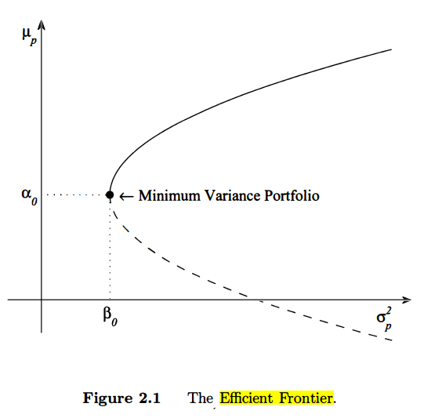

Figure 3.1 An illustration of an efficient minimum variant portfolio

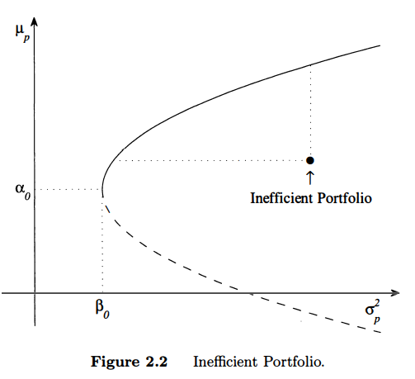

Figure 3.2 An illustration of an inefficient portfolio

The arbitrary constants $α_{0}$ and $β_{0}$ are the expected return and variance of the minimum variance portfolio.

By moving along the frontier, the point of maximum efficiency can be found, at the point where the frontier meets the imposed constrains which is usually determined by the Sharpe Ratio which can be defined as the ratio of every unit gain against the volatility the stock faces (risk).

## Candle Sticks

Visual representation is often preferred over raw numbers, candle stick charts prove to solve the problem by visualising the market OHLC data (Open, High, Low, Close of a stock’s price). There are two types of candle stick charts popularly used,

1. Normal Candle stick chart
2. Heikin-Ashi Candle stick chart

The normal candle stick charts provide the OHLC information about a stock and hence move along with the stock. This can cause the chart to capture all the stocks movement and noise. On the other hand, Heikin-Ashi charts which use a different formula tend to highlight stock movement trends along with their price movements.

Both the visuals have their pros and cons. The normal candle stick chart highlights the actual movement along with the noise while Heikin-Ashi candle sticks smoothen the chart but does not give the actual values of the stocks in question (because they smoothen the data, a bit of data loss/transformation occurs).

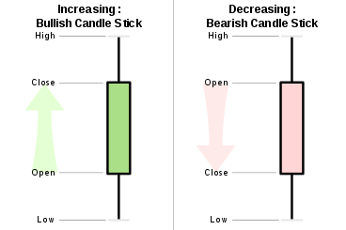Figure 3.3 Classical representation of a candlestick

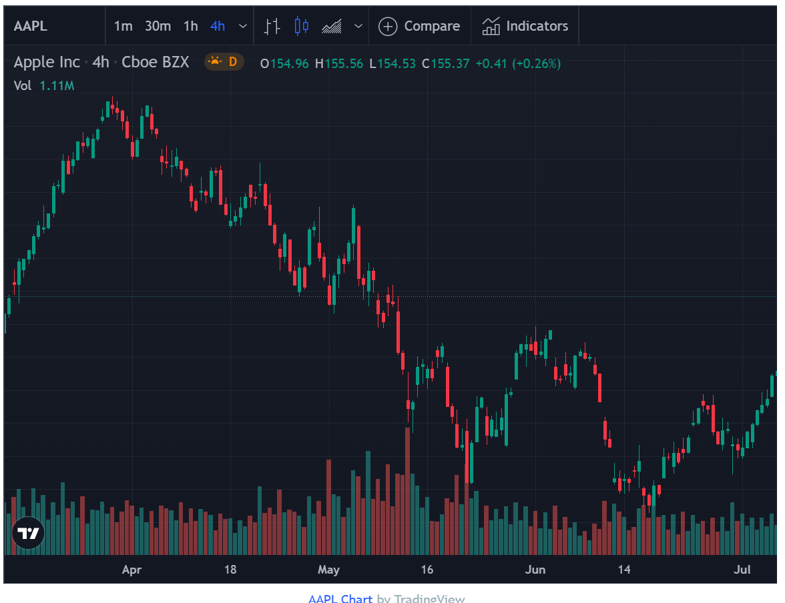Figure 3.4 A candlestick chart for the Apple stock

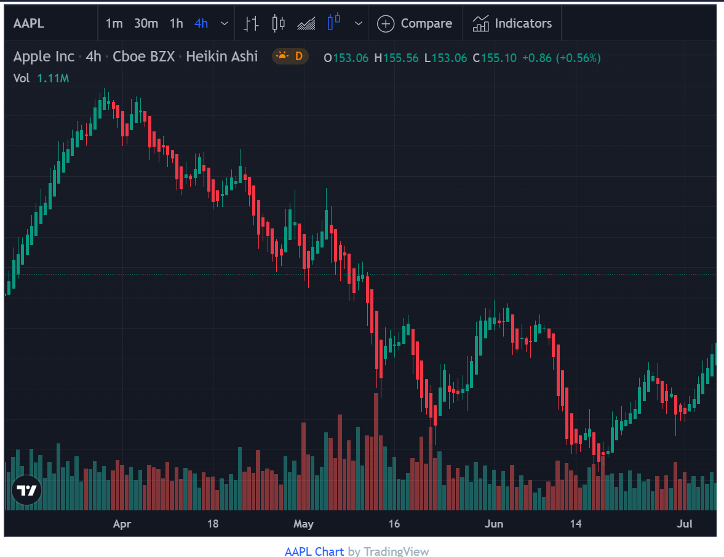Figure 3.5 A Heikin-Ashi candle stick for Apple Stocks

By comparing Figure 3.4 and 3.5, a difference can easily be seen between normal candlestick and a Heikin-Ashi candlestick. Figure 3.4 contains the actual stock prices and hence has more noise but the Heikin-Ashi candlestick has less noise but does not reflect the actual stock prices as the data used for the chart underwent smoothening.

## Technical indicators

“Make hay while the Sun shines” is a classical proverb which say about the importance of action done at the right time, similarly buying and selling apt is important. The knowledge of when to buy or sell can be achieved by performing technical analysis using different techniques. Few of them being,

1. Relative Strength Index
2. Moving averages
   1. Simple moving averages
   2. Moving average convergence / divergence
3. Bollinger bands

### Relative Strength Index

Relative Strength Index (RSI) is an index which describes the amount of oscillation a stock faces. Relative strength of a stock is calculated as

$$RSI=100−\frac{100}{1−RS}$$

where Relative Strength (RS) is calculated by

$$RS=\frac{SMMA\left(U,n\right)}{SMMA\left(D,n\right)}$$

Where U and D are metrics calculated for change in closing price between two days. The function SMMA (), is a smoother or modified moving average taken for ‘n’ periods (days). If the market if rising, D is zero while U is the difference between the closing price of the stocks between two consecutive days, this logic is converse for a falling market where U is zero while D is the difference in closing price of consecutive days. RSI gives the current moment of the stock; this indicator is like a percent indicator. RSI values between 70 – 30 is considered as normal for a stock’s momentum while outside of the said bounds could me that the stock is over-bought or over-sold.

### Moving Averages

Moving averages as the name suggests are averages of the stock prices taken at an interval of ‘n’ days where ‘n’ is the number of consecutive days considered for taking the average. Buy-sell signal can be generated using the help of moving averages, consider two set of moving averages one long-term and one short-term moving average. Whenever the short term moving average is greater than the long term moving average and vice-versa, we can generate a signal to buy or sell respectively. This is a simple trading trick achieved by using moving averages. A more sophisticated trick is by using moving average convergence and divergence technique. This technique uses the idea of stock divergence to generate signals. Divergence is a term which is used to indicate that the “indicator” used and the stocks are moving in the opposite direction and a trend reversal is imminent.

### Bollinger Bands

Bollinger bands are a simple and powerful technique to generate signals. By considering the stock price variation and setting a limit like ‘x’ standard deviations, we can create a boundary around the stock which when crossed signals a buy / sell.

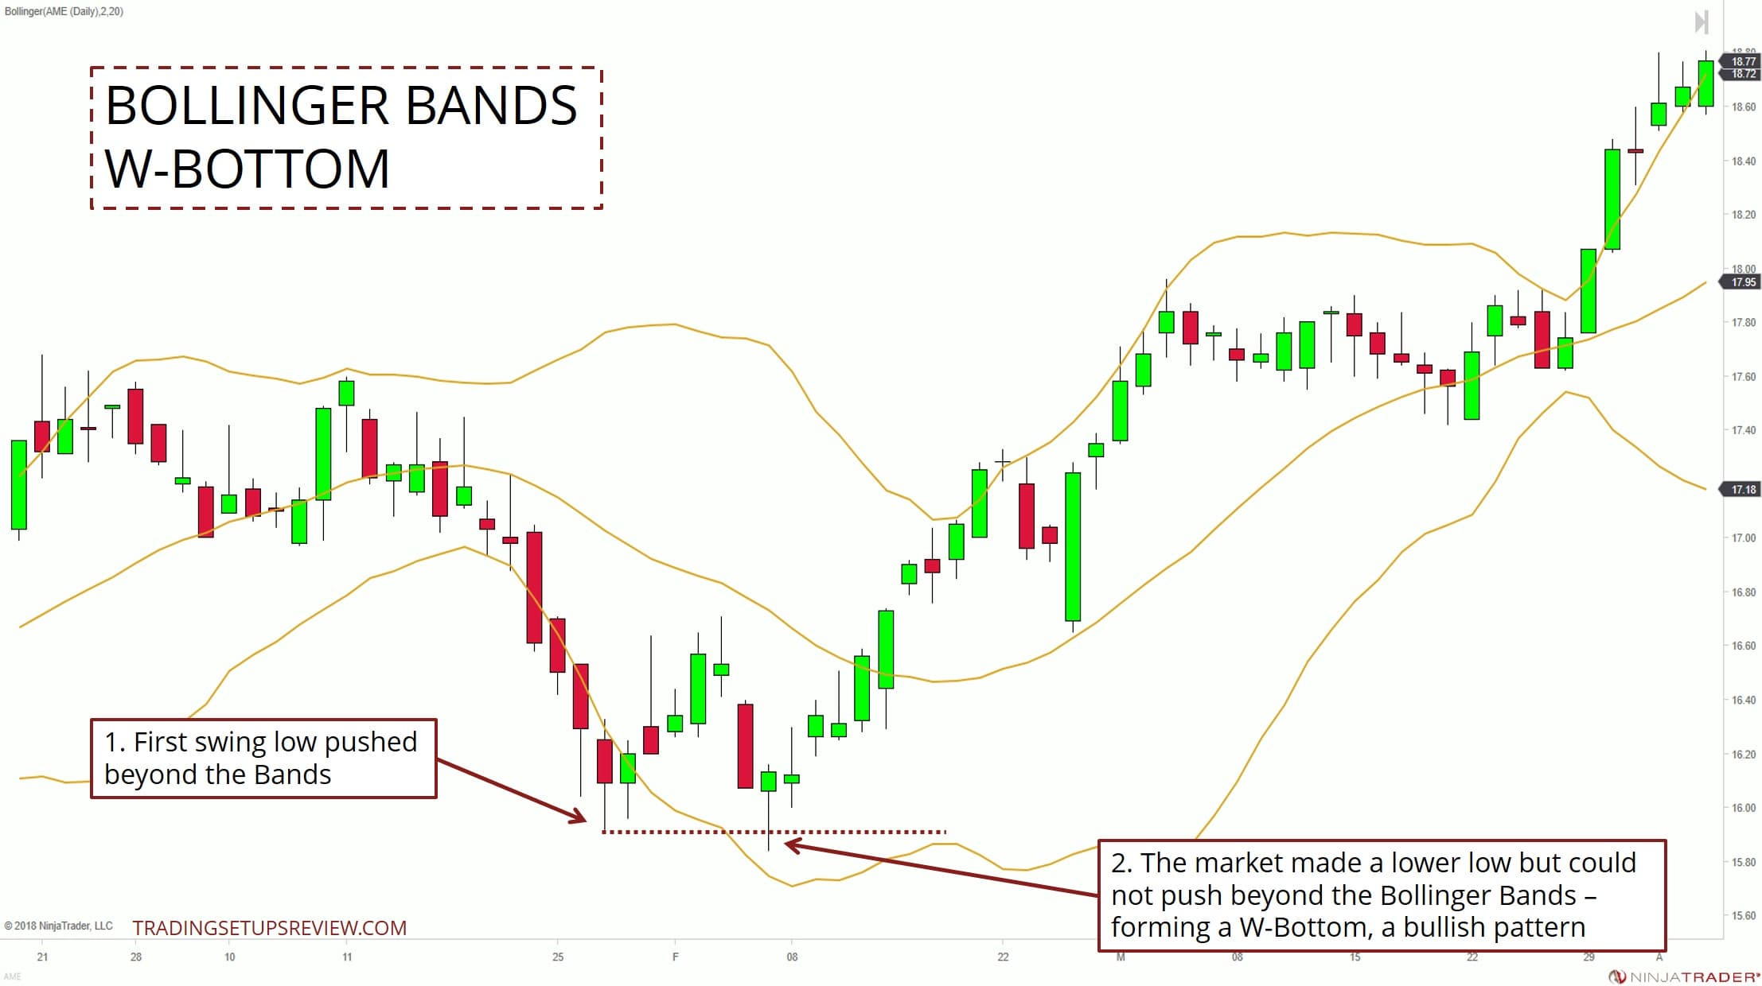Figure 3.6 A Bollinger Band chart

## Sentiment Analysis

Internet is the current means through which information is traversing the world and social media has become the most influential network across the globe. By performing sentiment analysis on social media and news articles, we can capture an idea of the stock movement for a short term. The nltk library used VADER (Valence Aware Dictionary and Sentiment), a lexicon / glossary as well as a rule-based sentiment analysis tool that is specially tuned to sentiments expressed on social media. The API like snscrape and GoogleNews are used to gather information from the internet. Once all the raw data has been gathered, we proceed to summarize the aggregate information to make meaningful analysis and an interpretation.

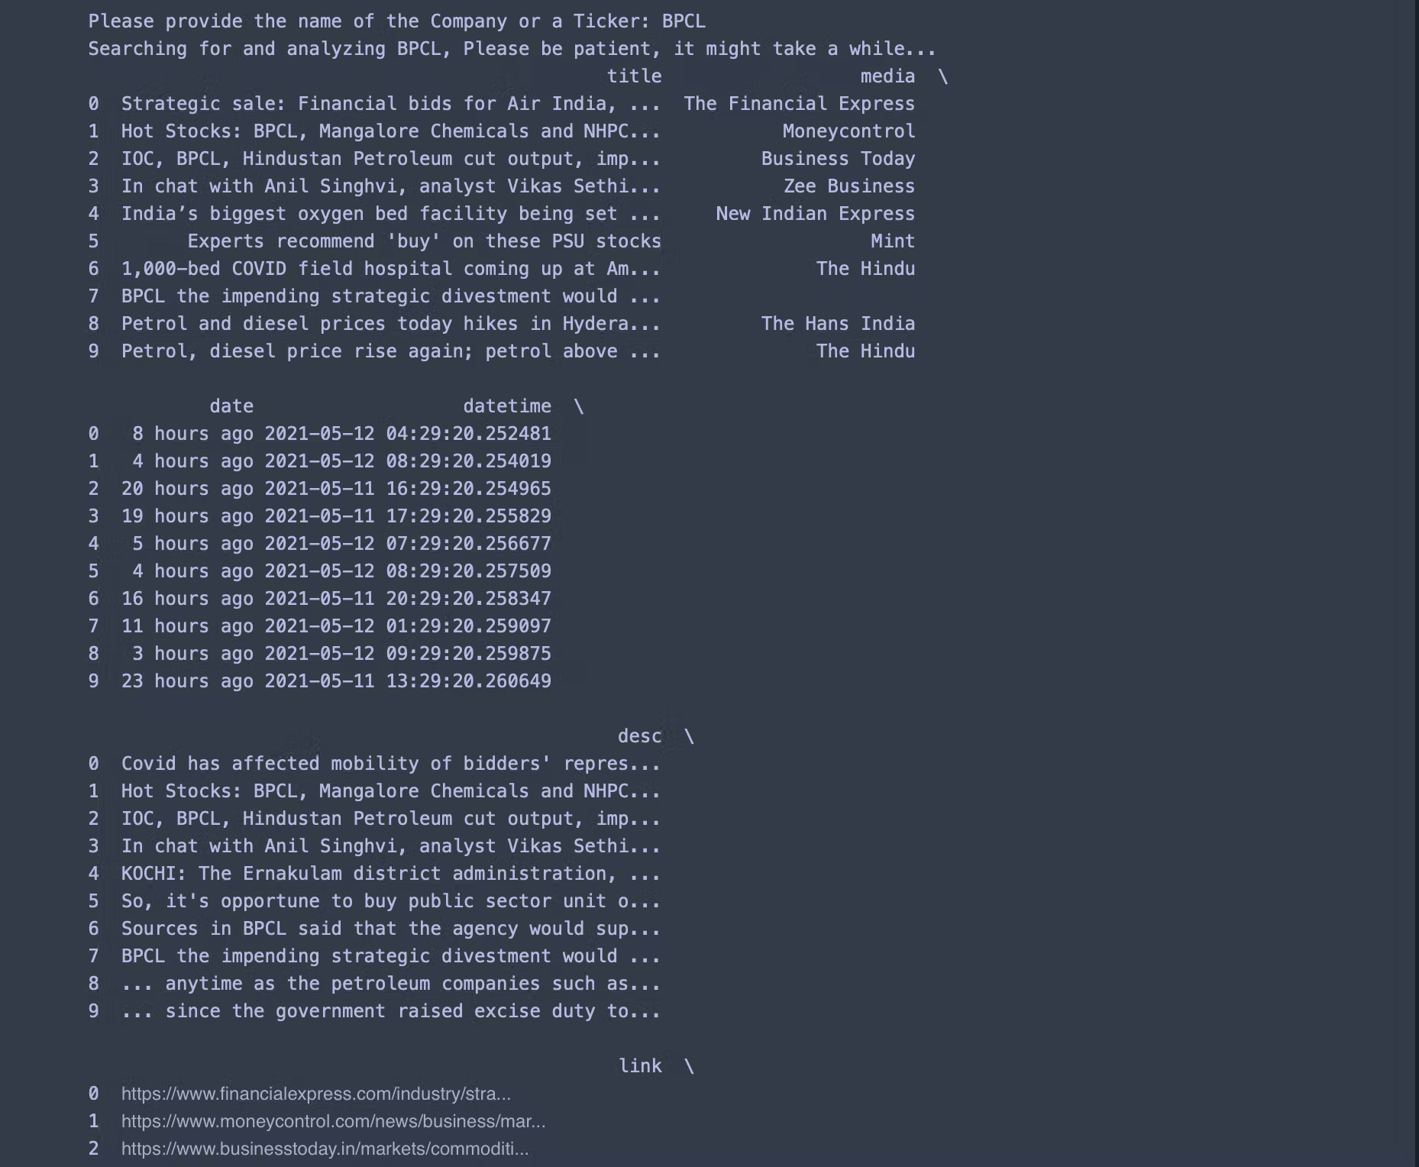Figure 3.7 A chunk of raw data collected from the internet using Google News API.

This info is useless by itself but, by generating a word cloud, it could make some useful interpretation. A word cloud is a representation which is used to represent words in the metadata on website or showcases the occurrence of words in a given phase or paragraph.

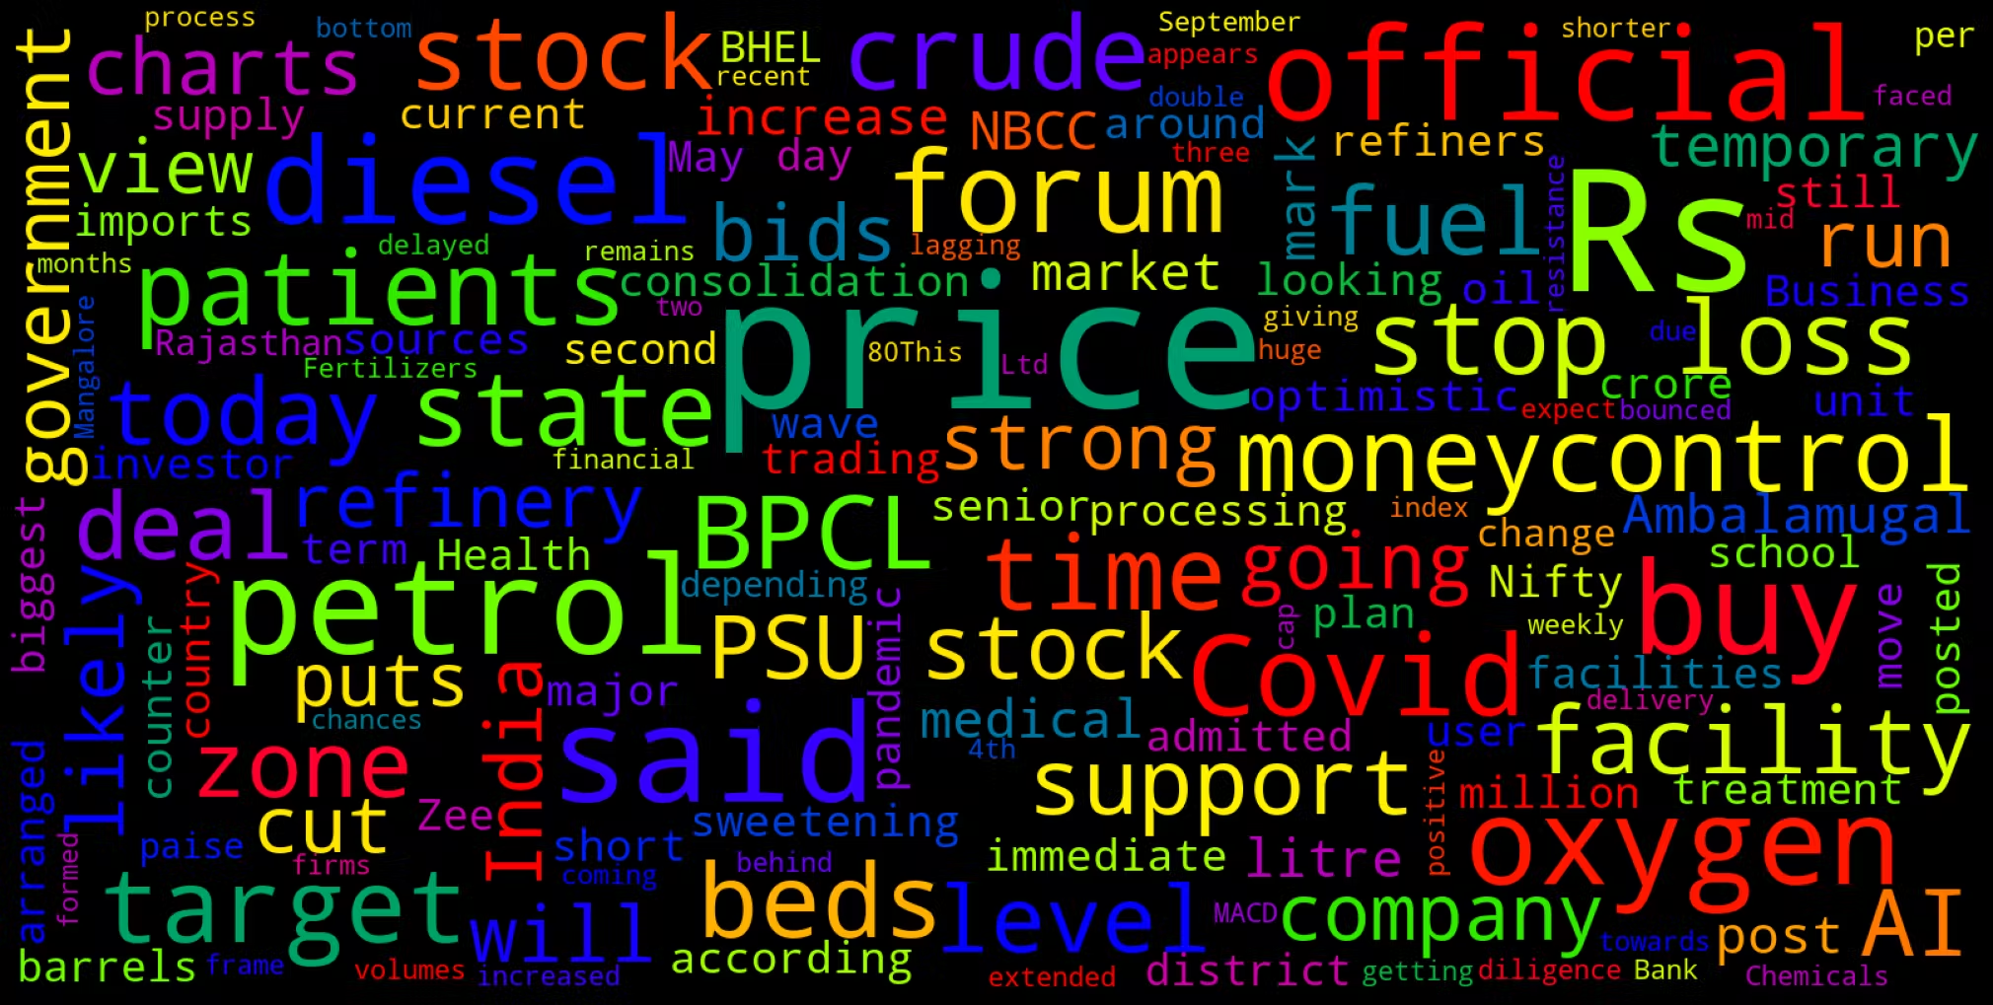Figure 3.8 a word cloud generated from the chunk of raw data collected

This word cloud highlights certain phrases like ‘price, petrol, target, stock’ etc. Among other words. But, still the analysis can be made better by aggregating the emotion of the words / phrases by using nltk’s VADER[12] using which we can gather the percentage of positive, negative and neutral emotions expressed in the internet. VADER is a short form for Valance Aware Dictionary and sEntiment Reasoner, which is a lexicon in nltk which uses rule based sentiment analysis to compute sentiment score.

# Modules

The project has two modules thus far implementing two key features of the project.

//diagram system flow

//modules – description, no need of charts

## The Stock Tracker and Optimizer

This module of the project implements the task of collecting and processing information related to how a given stock performs in the market. By tracking the price movements, percentage of gains across time and calculation of returns generated by the stock per rupee invested. These indicators can be taken as key factors that reveal a stock’s movement in a portfolio. By mathematically optimizing a basket of stocks, an optimal volume of investment can be visualized by this module.

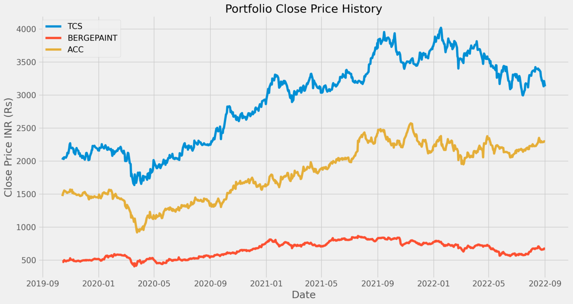

Figure 4.1 End Of Day prices of TCS, Berger Paint and ACC

// reduce its size

// include inference ... xaxis yaxis comparison: result data value based, year based, % max min

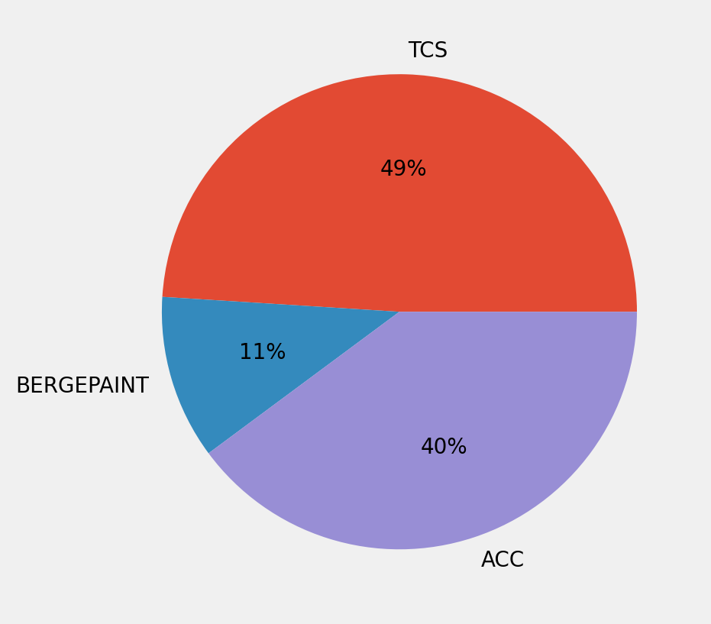Figure 4.2 A sample portfolio allocation between Berger Paints, ACC and TCS

## The Sentiment Analyser Module

The Second important module of the project is the sentiment analyser module which pools in data from twitter and Google News to make sense of how a stock is being treated in the market. This is of necessity because social media has proven to influence many walk of life. By using the VADER lexicon dictionary, we can make out the sentiment of the words gathered from the internet.

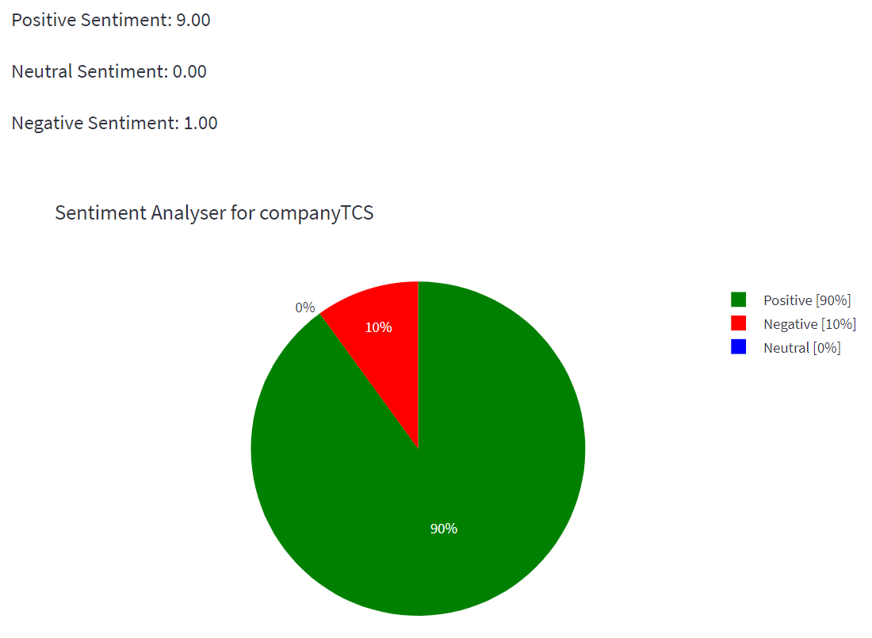Figure 4.3 A Sentiment Pie for Tata Consultancy Services

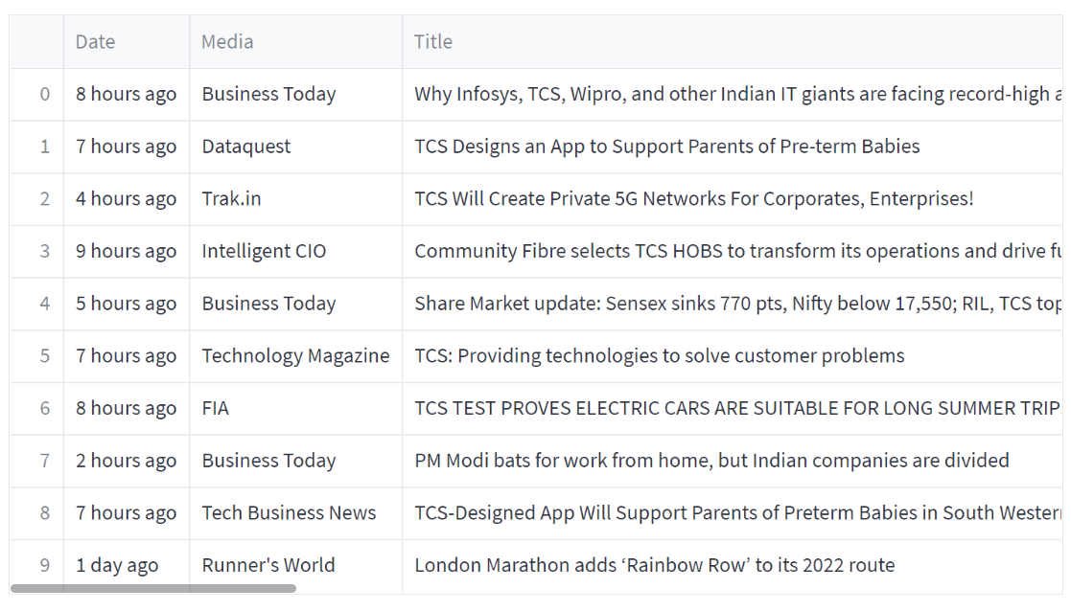Figure 4.4 A gist of the news articles collected from Google News

# Results and Discussion

## Results

//project --- in this proposed work

The project yielded expected results based on the mathematics involved. The tools used in the project confirms that there is a definitive relationship between risk and return but not to the extent to say that all risky stocks pay-off.

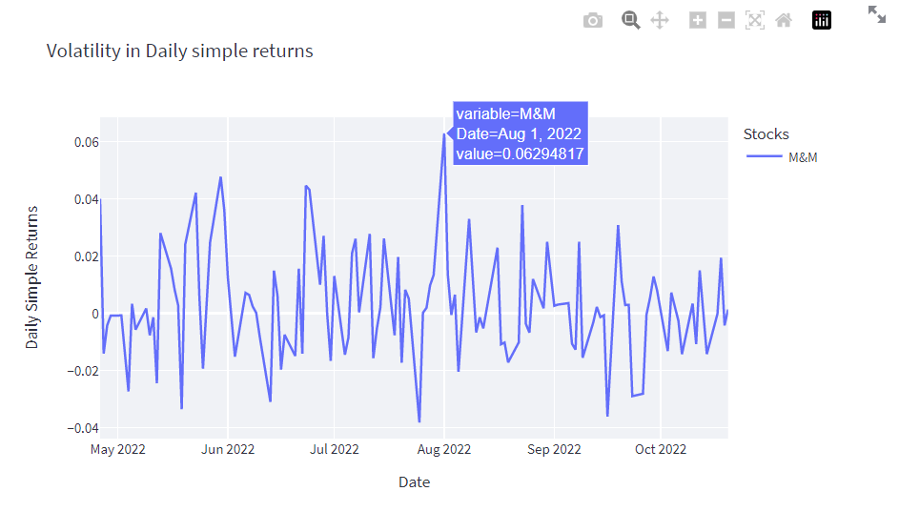Figure 5.1 A figure depicting a stock with high risk and relatively high return

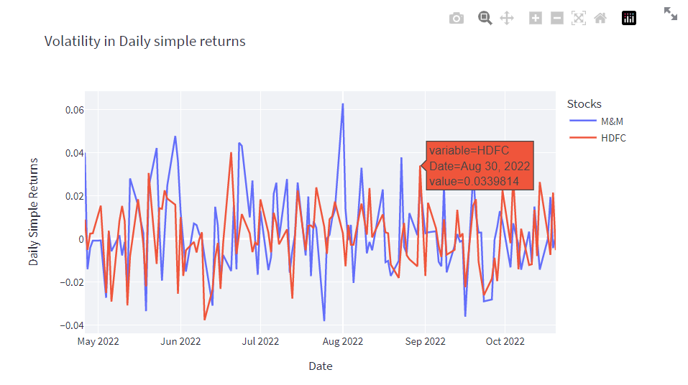Figure 5.2 is a similar figure as 5.1 but this show cases 2 stocks rather than 1

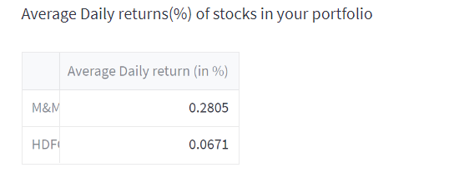Figure 5.3 Depicts the average daily return seen on the selected stocks

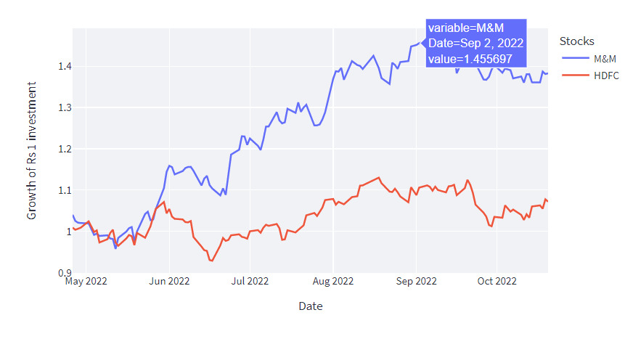Figure 5.4 Depicts the price change seen in the stock in the observed time for a rupee’s worth of investment

Average daily return of a stock is the average price increase seen in the stock in the selected period of time. It can be considered as the gain in the price of stock for a rupee’s investment.

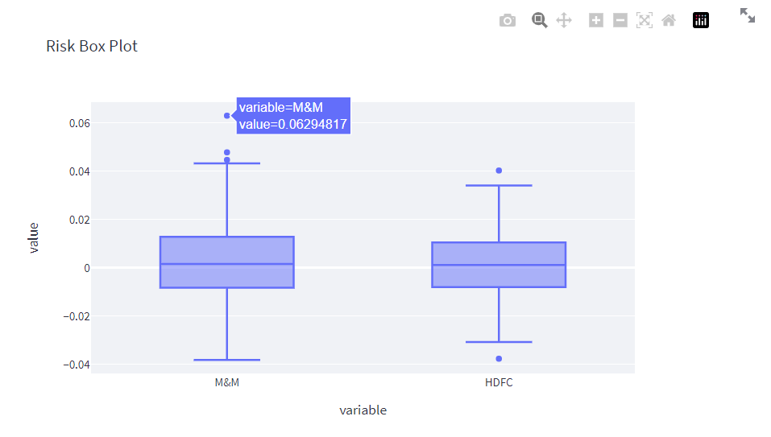

Figure 5.5 Shows the volatility of selected stocks in the form of a box plot

This figure shows-cases the maximum and minimum volatility seen in the stock visualised in the form of a box pot which shows the distribution on price volatility among the selected stocks.

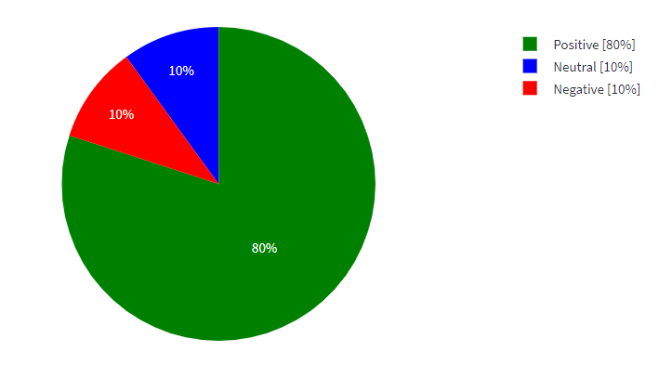

Figure 5.6 Show the sentiment score for a company

There were also some relationship between the sentiment of the user and stock prices and the sentiment of the users involved in the market. A positive trend among the users shows signs of a bullish trend and vice versa.

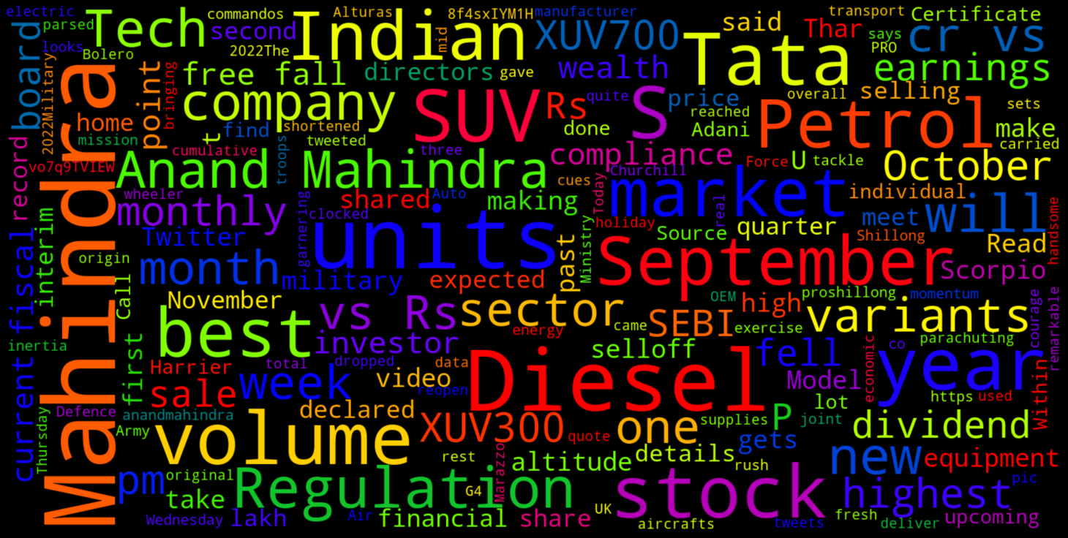Figure 5.7 Depicts the word cloud generated for a particular company

Sentiment analysis aims to find the sentiment of users online, but in order to know more about the actuality of things, a word cloud visual comes in handy by displaying the words people mostly use to describe the things they search.

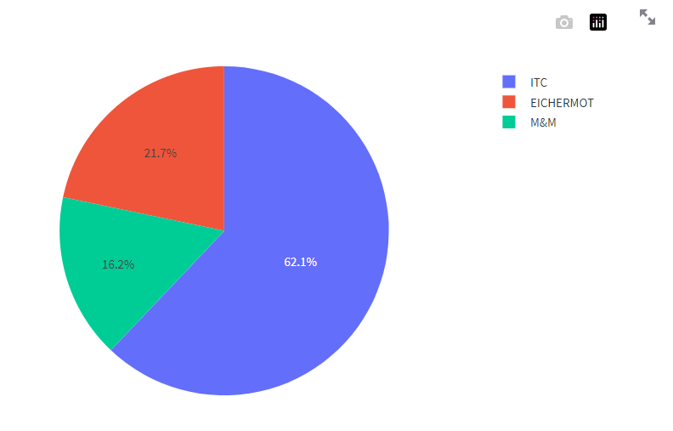Figure 5.8 Shows how the portfolio allocation is done for a trio of stocks selected

Portfolio Optimisation done using the pyportfolioopt module yields a result very much mathematically. The module prioritises a stocks return over the nature of choice and it mainly used the Sharpe ratio to calculate the portfolio allocation.

Overall view about your analysis

## conclusion

The dependency on internet and python have been the most dragging aspect of the project. The project also provided / reconfirmed that stock market predictions using conventional and newer machine learning models still misses features that are necessary for accurate predictions (An ARIMA model and an LSTM for predictions were tried but failed to yield substantial results as neither had an accuracy more than 80 % accuracy). This project also confirms the volatility of the market and its dependency on the mindset of investors, intrinsic and extrinsic factors like the nature of company, economic conditions. The sheer volume of knowledge and information required to process the entire data proved monumental when compared to the time of the project. The portfolio optimisation module mainly prioritised return over choice which could be a draw-back should the user try to create their own portfolio with a notion in mind.

# Reference

1. Technical Analysis of Stock Trends, By Robert D. Edwards, John Magee, W. H. C. Bassetti
2. Portfolio Optimization by Michael J. Best
3. Using The Heikin-Ashi Technique by Muhammad Iqbal
4. John Bollinger
5. Using Bollinger Bands by John Bollinger
6. Back testing Value-at-Risk: A Duration-Based Approach by Peter Christofferson, Denis Pelletier
7. entiment analysis on social media for stock movement prediction by Thien HaiNguyena, Kiyoaki Shiraia, JulienVelcinb
8. Security Analysis and Portfolio Management, Chandra Prasanna
9. Combining Enterprise Knowledge Graph and News Sentiment Analysis for Stock Price Prediction, Jue Liu, Zhuocheng Lu, Wei DU, Renmin University of China
10. Examination of the profitability of technical analysis based on moving average strategies in BRICS, Matheus José Silva de Souza, Danilo Guimarães Franco Ramos, Marina Garcia Pena, Vinicius Amorim Sobreiro & Herbert Kimura
11. A comprehensive review of deterministic models and applications for mean-variance portfolio optimization, Can B. Kalayci , Okkes Ertenlice , Mehmet Anil Akbay
12. Hutto, C.J. & Gilbert, E.E. (2014). VADER: A Parsimonious Rule-based Model for Sentiment Analysis of Social Media Text. Eighth International Conference on Weblogs and Social Media (ICWSM-14). Ann Arbor, MI, June 2014.